**What to expect following the BCG vaccination – RCH Parent Handout*.***

Adverse reactions to vaccines (also known as ‘vaccine side effects’) do sometimes occur. The BCG vaccination is given just under the skin (into the ‘intradermal’ layer) of the left upper arm and is sometimes associated with common and rare

side effects.

This RCH parent handout provides information about side effects of the BCG vaccine as well as suggestions on minimising the risk.

# Signs and symptoms

The usual expected reaction to BCG vaccination is redness and/or a small lump at the injection site, followed by a small ulcer (open sore) a few weeks later (usually less than 1 cm in diameter). The ulcer may last from a few weeks to months before healing to a small flat scar.

**How to care for the vaccination site**

* Keep the site clean and dry
* If a sore develops, a gauze dressing is able to be applied

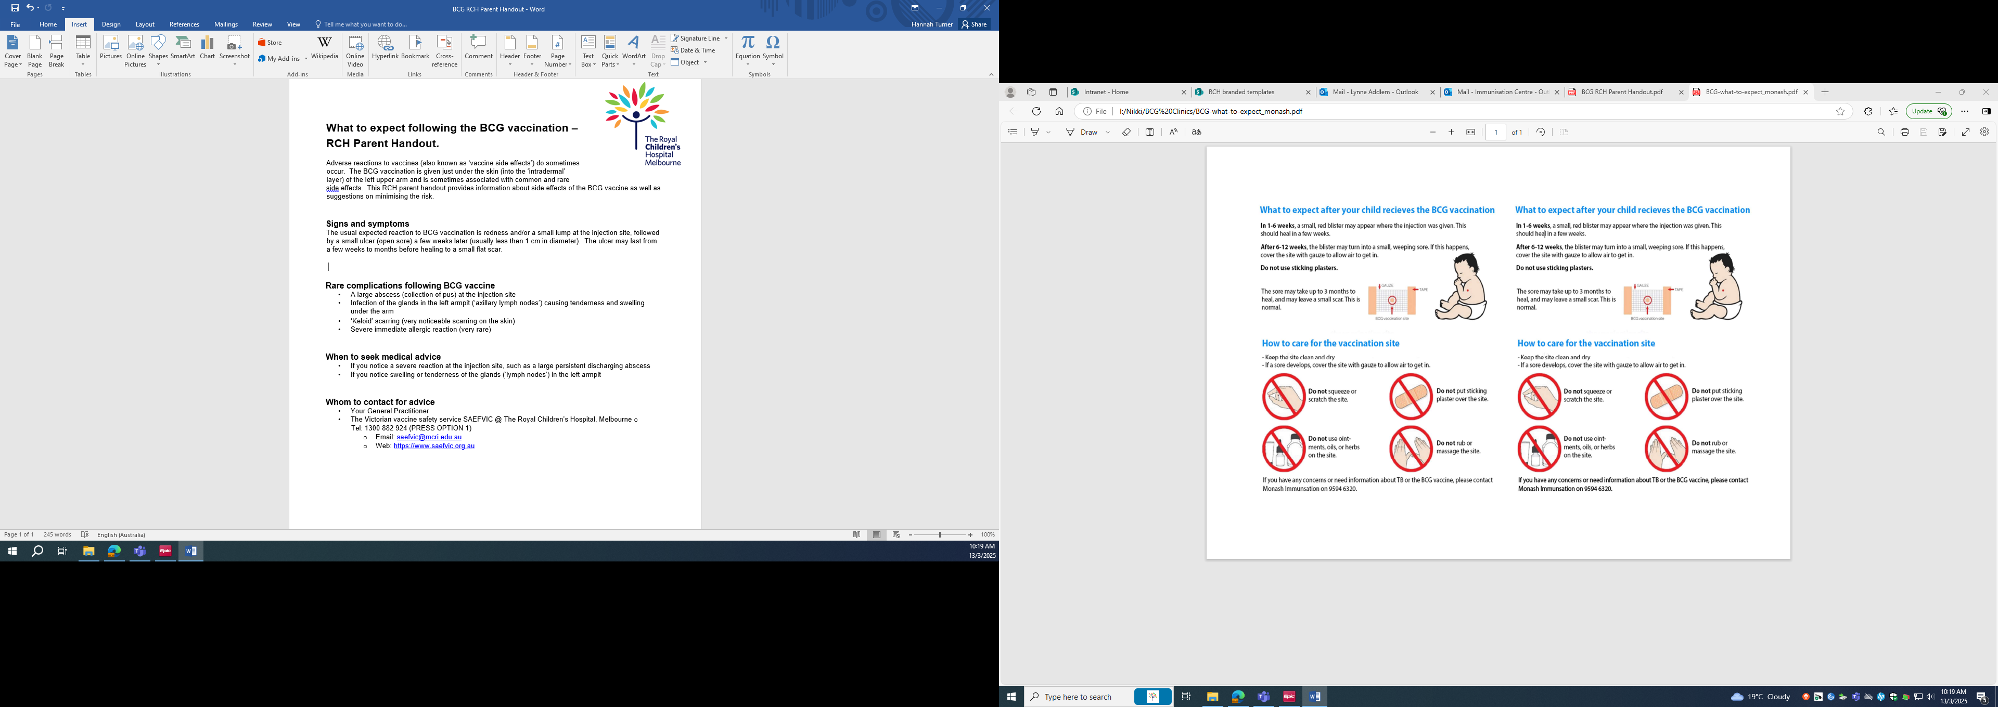

# Rare complications following BCG vaccine

* A large abscess (collection of pus) at the injection site
* Infection of the glands in the left armpit (‘axillary lymph nodes’) causing tenderness and swelling under the arm
* ‘Keloid’ scarring (very noticeable scarring on the skin)
* Severe immediate allergic reaction (very rare)

# When to seek medical advice

* If you notice a severe reaction at the injection site, such as a large persistent discharging abscess
* If you notice swelling or tenderness of the glands (‘lymph nodes’) in the left armpit
* Treatment with antibiotics or antibiotic creams is not required or recommended
* It is not recommended to squeeze the site, perform needle aspiration or cut the site open. Swelling at the site will self-resolve.

# Whom to contact for advice

* Your General Practitioner
* The Victorian vaccine safety service SAEFVIC @ The Royal Children’s Hospital, Melbourne

o Tel: 1300 882 924 (PRESS OPTION 1)

* + Email: saefvic@mcri.edu.au
  + Web: [https://www.saefvic.org.au](https://www.saefvic.org.au/)